BUILDING HOPE:
PSYCHOLOGICAL CONTRIBUTIONS
TO A ROADMAP FOR
CLIMATE ACTION
15th Psychology Day at the United Nations convened
Report written by: Vica Tomberge, Kalyani Gopal, Efrat Neter, Vera Araujo-Soares (Psychology Coalition of the United Nations)

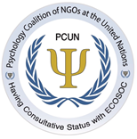

The 15th Annual Psychology Day at the United Nations was dedicated to climate change and focused on how psychology can contribute and support countries in implementing their climate pledges.
Virtually carried out via zoom it took place on Thursday, April 21, 2022 and was sponsored by the Psychology Coalition of NGOs at the United Nations having Consultative Status with ECOSOC and the Permanent Missions of the Dominican Republic and Mexico to the United Nations. 2677 people registered and 640 from 107 countries attended to discuss this year´s theme "Building Hope: Psychological Contributions to a Roadmap for Climate Action”.
During his opening speech, David Marcotte, Ph.D., President of the Psychology Coalition of NGOs at the United Nations, emphasized the importance of the PCUN network of NGOs to contribute to the fight against climate change and all contemporary challenges with transdisciplinary, international effort.
Further opening remarks were shared by Kalyani Gopal, Ph.D., President of Division 12 of the American Psychological Association (APA). Dr. Gopal stated that psychologists need to provide their knowledge on reducing environmental stress and fighting eco-harmful strategies to collectively reduce our carbon print.
Following Dr. Gopal’s opening note, Dr. Vera Araújo-Soares (Regional Vice President at the Psychology Coalition of NGOs at the United Nations, University of Twente, Netherlands) and Dr. Efrat Neter, (Ruppin Academic Center, Emeq Hefer, Israel, and Secretary at the Psychology Coalition at the United Nations) moderated the ensuing speakers.
Mr. Abdulla Shahid, President of the United Nations General Assembly, addressed the audience and emphasized the importance of hope, the central theme of his presidency, in addressing climate change, as hope is a common denominator for human collective action. He stated that psychological solutions are needed today more than ever and warmly welcomed PCUN’s commitment to sharing how can psychological science contribute to tackle climate change.

Afterwards Ambassador J. R. de la Fuente, Permanent Representative of Mexico to the United Nations and founder of the Clinical Research Unit of the Mexican Institute of Psychiatry reaffirmed the view that combating climate change requires an international and coordinated response, including addressing the mental health consequences that may arise.
Following these remarks, a panel of six psychologists from five different continents and varied psychological disciplines, emphasized the potential contributions of psychological perspectives to actionable solutions to the climate change.
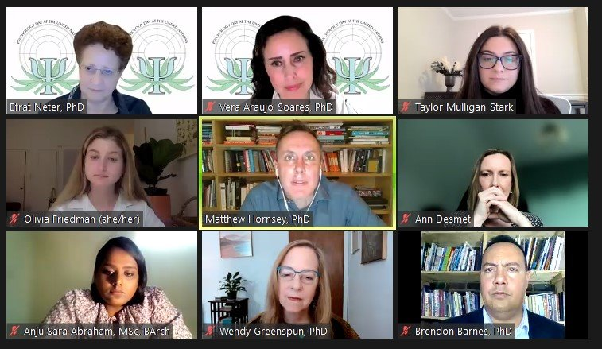
Some of the Presenters on the Psychology Day.

As the first presenter, Wendy Greenspun, Ph.D., (Manhattan Institute for Psychoanalysis and the Adelphi University, USA) in From Tears to Hope and Courage described multiple forms of climate distress and trauma being experienced by communities worldwide. Dr. Greenspun particularly highlighted that young people face a foreshortened future and historically marginalized communities suffer layers of environmental harm and injustice. Building on this, Dr. Greenspun presented multiple ways of building emotional resilience such as calming, finding purpose and living connection and solidarity.
Talking about Psychology and Climate
Acton in the Global South, Brendon Barnes, Ph.D., (University of Johannesburg, South Africa) emphasized that psychology needs a clearer focus on the local realities of marginalized people. In order to mitigate global, intersectional climate injustice and to allow climate movements to decentralize, he suggested the use of digital platforms. He pointed out four areas worthy of psychologists’ attention in the global South: making climate and psychology evidence digitally accessible, developing digital technologies for interventions, actively changing digital media representations, and using psychology to enhance digital climate mobilization.

Anju Sara Abraham, (Psychologist, Senior Architect, Council of Architecture and the Indian Institute of Architects) spoke about “Using Architecture and Design to promote Mental Health and Enhance Positive Climate Action” focusing on the relationship of architecture, health and sustainable development. She explained that architecture can provide a range of incentives to ‘nudge’ users to be active and behave in a sustainable way, e.g. by incorporating 'walkability' within the city resulting in greater proximity to facilities and destinations or by designing indoors improving the air quality, temperature good daylight within the building structure in order to facilitate responsible use of resources.
Matthew Hornsey, Ph.D., (University of Queensland, Australia) talked about Understanding (and reducing) Climate Change Skepticism. He gave an insight on the psychological profile of climate skeptics, i.e. people who deny climate change and its causal relation with human behavior. Raising up the concept of motivated reasoning, he called for promoting climate-friendly behavior by aligning with skeptics’ underlying ideologies, anxieties, and identity needs instead of competing with them by presenting ‘the evidence’.
Finally, Ann DeSmet, Ph.D. (Université Libre de Bruxelles, Belgium) spoke about Health Behaviors by Addressing Spill-over and Shared Underlying Determinants, pointing out how health and environmentally friendly behavior can complement each other and promote the health of the planet. However, negative spillover effects (when one behavior reduces the likelihood of adopting another behavior) or positive spillover effects (when increased skills increase the likelihood of adopting an additional behavior) must be considered. Building on this, Dr. De Smet pointed out that targeting a change in multiple behaviors is essential to create a planetary health impact.

In response to these presentations, Dr. Vera Araújo-Soares integrated the contributions in Bridging Intersectionality between Psychology and Climate Action, highlighting inequities emerging as a central theme. Dr Araújo-Soares also presented extensive evidence on the positive and negative role that health-related behaviors can play in climate change mitigation and adaptation. She calls for behavioral interventions to specifically target health equity, use scientifically proven mechanisms of action, engage with users and stakeholders to ensure uptake, and consider contextual constraints.
The presentations were followed by a 30-minutes Q & A session. Closing remarks were given by Dr. David Marcotte and Dr. Kalyani Gopal; Dr. Marcotte presented a PCUN statement on current events in Eastern Europe.
The 2022 UN Psychology Day was organized by a 25-person committee and led by Kalyani Gopal, Efrat Neter, Vera Araujo-Soares, Olivia Friedman, Taylor Mulligan, and Josephine Juanamarga.
Details on the Day appear at https://www.unpsychologyday.com/ and the whole record of the event can be found online: https://www.youtube.com/watch?v=NQwXPQ8mz4U

