Front of medal

**Nancy Sidun, Ph.D. President, APA Division 52 2019**

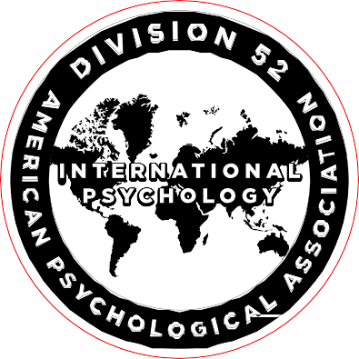

**Brigitte Khoury, Ph.D. President, APA Division 52**

**2020**

Back of medal

*Item # MA5116*

*7.5” Gavel*

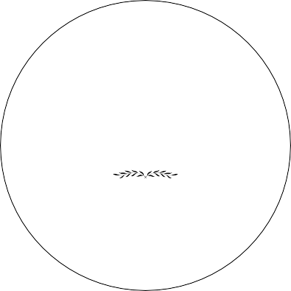

**APA Division 52**

**Outstanding International Psychologist**

**2019**

**Reza Zamani**

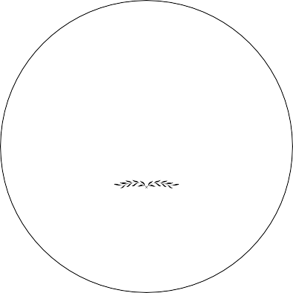

**APA Division 52**

**Outstanding International Psychologist**

**2019**

**Elena Grigorenko**

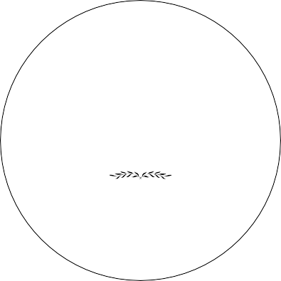

**APA Division 52**

**Anastasi Graduate Student Research Award**

**2019**

**Tyler Collette**

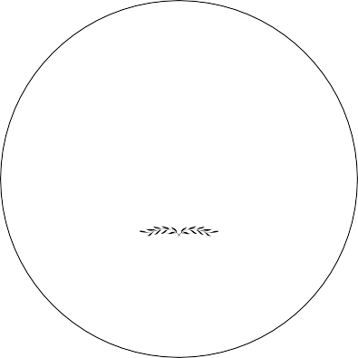

**APA Division 52**

**Anastasi Graduate Student Research Award**

**2019**

**Stelios Syropoulos**

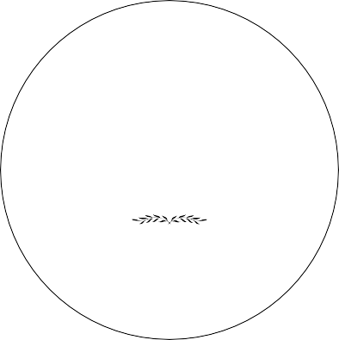

**APA Division 52**

**Henry David International Mentoring Award**

**2019**

**Chiachih DC Wang**

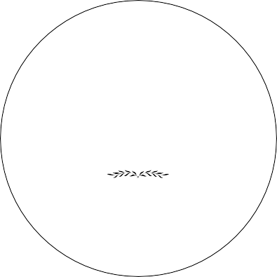

**APA Division 52**

**Outstanding Early Career Psychologist**

**2019**

**Laura Dryjanska**

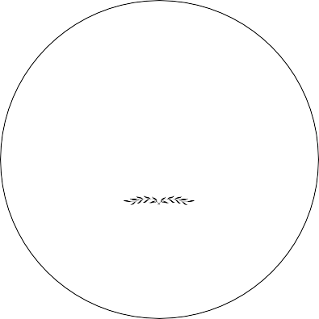

**APA Division 52**

**Outstanding Early Career Psychologist**

**2019**

**Juan A. V. Vazquez**

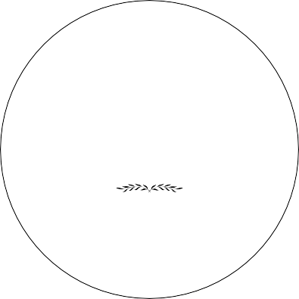

**APA Division 52**

**Student International Research Award**

**2019**

**Madeline Stenersen**